SIMATS ENGINEERING (SAVEETHA SCHOOL OF ENGINEERING)
Department of Computer Science and Engineering
CO2 ASSESSMENT TOOL 1 – Scenario-Based Requirement Analysis
Course Code: CSA1023 | Course Title: Software Engineering
CO Assessed: CO2 | Assessment: Assessment Tool 2 – Scenario-Based Requirement Analysis
Weightage: 20% | Total Marks: 25

CO2 Statement: Perform detailed requirements analysis, design scalable architectures, and prioritize features with a focus on cross-disciplinary skills
Student Name: Shaik Afra Aiman | Reg. No: 1911260142
Date: 23-10-2026 | Duration: 60 minutes

Code of Conduct
I Shaik Afra Aiman (1911260142) certify that this submission is my original work and that I have adhered to the guidelines specified for this assessment. I understand that any violation of academic integrity rules will result in disciplinary action.
Signature of the Student: Afra

SOFTWARE REQUIREMENT ANALYSIS
Problem Statement 34
Intelligent Public Service Complaint Resolution Platform
1. Study and Analysis of the Scenario
1.1 Problem Statement
The problem statement assigned to me is number 34, the Intelligent Public Service Complaint Resolution Platform. In the given scenario, public organizations receive a large number of complaints about roads, water, sanitation, transport, utilities and other civic services. At present these complaints are classified and routed manually. This causes delay in resolution and makes it hard to measure how well each department is performing against its service-level targets.
The task is to design and develop a platform that classifies the complaints, prioritizes them, routes them to the right department, tracks progress and keeps the citizen informed with status updates. The platform must support scalable APIs, role-based access, workflow automation, monitoring, analytics, testing and CI/CD. The automated classification must stay open to review and transparent, which means a human should be able to see why the system took a decision and change it if needed.
1.2 Business Domain
The system belongs to the e-governance and public service delivery domain (civic grievance redressal). The users are citizens on one side and municipal or government departments such as Roads, Water Supply, Sanitation, Transport and Electricity on the other side. The business value is not profit; it is faster service, accountability and public trust. Because the data is public in nature but also contains personal details of citizens, privacy and audit requirements are important along with the usual functional needs.
1.3 Stakeholders
Table 1: Stakeholders of the system and their interest
Stakeholder | Role in the system | Main interest / expectation
Citizen | Raises complaints, tracks them, gives feedback | Easy submission, quick resolution, regular updates, no need to visit offices
Department Officer | Receives and resolves routed complaints | Clear task list, correct routing, realistic deadlines, simple way to update status
Supervisor / Department Head | Reviews doubtful classifications, reassigns, handles escalations | Control over workload, early warning on SLA breach, performance view
System Administrator | Manages users, roles, categories, rules and SLA settings | Easy configuration without code change, secure access, audit logs
Notification Gateway (SMS / Email) | External service that delivers messages | Correct message format, controlled request rate
Map / GIS Service | External service for address and ward lookup | Valid coordinates and API usage limits followed
Development and operations team | Builds, tests, deploys and monitors the platform | Clear requirements, modular design, automated pipeline and monitoring

1.4 Existing Challenges
Table 2: Challenges in the current manual process
No. | Challenge | Effect
1 | Complaints are classified by staff manually | Wrong or slow classification, complaint sits in the wrong queue
2 | No common rule for urgency or impact | A broken water main may wait behind a minor street light issue
3 | Routing depends on individual knowledge of staff | Complaints bounce between departments, poor coordination
4 | No tracking of service-level targets | Delays are noticed late, nobody is held accountable
5 | Citizens do not get status updates | Repeated follow-up calls and visits, loss of trust
6 | Duplicate complaints for the same issue | Wasted effort, inflated complaint numbers
7 | Paper records and heavy manual work | Little analytics, difficult audit, staff time spent on sorting

1.5 System Objectives
The objectives given in the problem statement were studied one by one and each one was converted into a system level goal. The mapping is shown below and it is used again in the validation section.
Table 3: Objectives and how the system addresses them
Obj. | Objective | How the platform addresses it
O1 | Collect and classify public complaints | Web and mobile submission with auto-classification and confidence score
O2 | Prioritize issues by urgency and impact | Rule based priority score with Critical, High, Medium, Low levels
O3 | Route complaints to responsible departments | Category and ward based routing rules, officer assignment, reassignment
O4 | Track resolution status and service-level targets | Status workflow, SLA timers, warnings and escalation
O5 | Citizen notifications and dashboards | SMS, email and in-app messages, tracking page, public dashboard
O6 | Secure APIs, testing, CI/CD and monitoring | Token based REST APIs, automated tests, pipeline, health metrics and alerts
O7 | Transparency and audit trails | Explainable classification, override with reason, tamper-evident audit log

1.6 System Context
Figure 1 shows the platform as one block with the external entities around it and the main data that flows between them. It helps to fix the boundary of the system before the requirements are written.
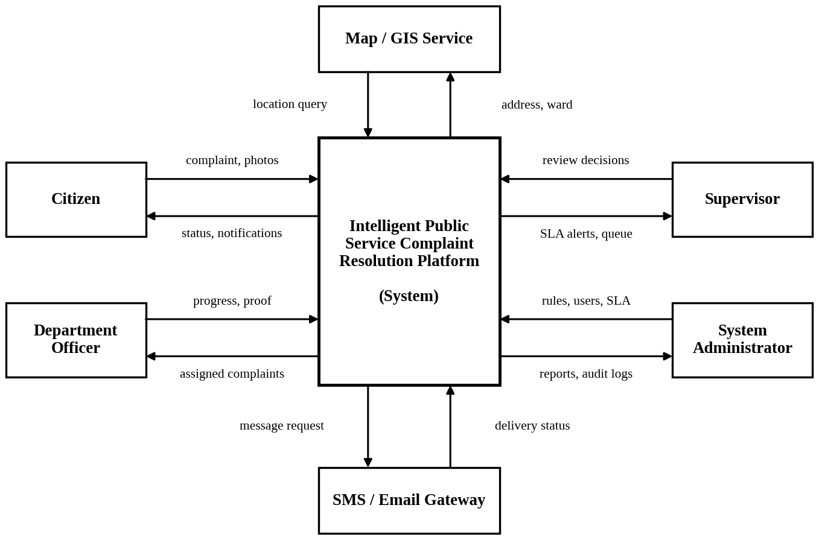
Fig. 1: Context diagram of the complaint resolution platform
2. Functional and Non-Functional Requirements
2.1 Functional Requirements
The functional requirements are grouped by module. Priority is given using the MoSCoW method (M = Must have, S = Should have, C = Could have).
Table 4: Functional requirements
ID | Requirement | Priority
Module A: User and Access Management
FR-01 | The system shall allow a citizen to register and log in using mobile number or email with OTP verification. | M
FR-02 | The system shall provide role-based access for Citizen, Department Officer, Supervisor and Administrator. | M
FR-03 | The administrator shall be able to create, update, deactivate users and assign roles and departments. | M
Module B: Complaint Collection
FR-04 | The system shall let a citizen submit a complaint with description, location (address, map pin or ward) and up to five attachments (photo, video or PDF). | M
FR-05 | The system shall accept complaint text in English and in the local language. | S
FR-06 | The system shall generate a unique complaint ID and show an acknowledgement immediately after submission. | M
FR-07 | The system shall detect probable duplicates (same category, nearby location, recent time) and link them to the open complaint. | S
FR-08 | The platform APIs shall be reusable by other channels such as a call center or messaging app in future. | C
Module C: Classification
FR-09 | The system shall automatically classify each complaint into a category and sub-category (roads, water, sanitation, transport, utilities, civic services). | M
FR-10 | The system shall store a confidence score and the keywords or rules that led to the classification. | M
FR-11 | Complaints below the confidence threshold shall be sent to a supervisor review queue. | M
FR-12 | A supervisor shall be able to correct the category, and the correction shall be saved with the reason. | M
Module D: Prioritization and SLA
FR-13 | The system shall calculate a priority level using urgency, impact, location sensitivity and repeat reports. | M
FR-14 | The score breakdown shall be visible, and a supervisor may override the priority with a written reason. | M
FR-15 | The system shall assign an SLA target based on category and priority, and the targets shall be configurable. | M
Module E: Routing and Workflow
FR-16 | The system shall route the complaint to the responsible department using category and ward-to-department mapping. | M
FR-17 | The system shall assign the complaint to an officer of that department based on zone and current workload. | S
FR-18 | An officer shall accept or decline an assignment; a declined complaint returns to the supervisor for reassignment. | M
FR-19 | The system shall follow the status workflow: Submitted, Classified, Routed, Assigned, In Progress, Resolved, Closed, Reopened, Duplicate/Rejected. | M
FR-20 | An officer shall add progress notes and upload proof of resolution. | M
FR-21 | A complaint that needs more than one department shall be transferable between departments with a transfer note. | S
Module F: SLA Monitoring
FR-22 | The system shall run an SLA timer, warn the officer at 75% of the time and mark the breach. | M
FR-23 | The system shall escalate a breached complaint to the supervisor and then to the department head. | M
Module G: Citizen Services and Notifications
FR-24 | The system shall notify the citizen by SMS, email or in-app message at every status change. | M
FR-25 | A citizen shall be able to track a complaint with its timeline using the complaint ID. | M
FR-26 | After resolution the citizen shall be able to confirm, rate, or reopen the complaint within 7 days. | S
FR-27 | The system shall provide a public dashboard with area-wise counts and average resolution time without showing personal data. | S
Module H: Analytics, Administration and Governance
FR-28 | The system shall give supervisors and administrators dashboards for volume, category trend, backlog, SLA compliance and department performance. | M
FR-29 | Reports shall be available for export in PDF and CSV format. | S
FR-30 | The administrator shall configure categories, keywords, department mapping, SLA rules, priority weights and the confidence threshold. | M
FR-31 | Every action shall be written to a read-only audit log with user, action, old value, new value and time. | M
FR-32 | The system shall keep a decision log of each automated classification with the model or rule version used. | M
Module I: Platform Services
FR-33 | The system shall expose documented and secured REST APIs for all functions used by the web and mobile applications. | M
FR-34 | The system shall expose health-check and metrics endpoints for monitoring. | M
2.2 Non-Functional Requirements
The non-functional requirements describe how well the system should work. Wherever possible a measurable target is given so that the requirement can be tested.
Table 5: Non-functional requirements
ID | Category | Requirement | Measure
NFR-01 | Performance | Pages and API calls shall respond quickly under normal load. | Page load within 3 s and read APIs within 500 ms for 95% of requests
NFR-02 | Performance | Automatic classification and priority calculation shall not delay acknowledgement. | Completed within 5 s of submission
NFR-03 | Scalability | The platform shall handle growth in complaints and users by adding instances. | 50,000 complaints per day and 5,000 concurrent users; horizontal scaling
NFR-04 | Availability | The platform shall be available for citizens at all times except planned maintenance. | 99.5% availability per month
NFR-05 | Reliability | A submitted complaint shall never be lost and failed notifications shall be retried. | RPO 15 min, RTO 2 hours, 3 retries for messages
NFR-06 | Security | Data shall be protected in transit and at rest and access shall be controlled. | TLS 1.2+, hashed passwords, token expiry, role check on every API, OWASP Top 10 checks
NFR-07 | Privacy | Personal details shall be visible only to authorized roles and hidden on public pages. | Masked phone and name in public dashboard; compliance with applicable data protection law
NFR-08 | Usability | A citizen shall be able to file a complaint without training on any device. | Form completed in under 3 minutes; responsive design; WCAG 2.1 AA; multi-language labels
NFR-09 | Maintainability | The system shall be built as modules with tests and documentation. | Unit test coverage of at least 70%; coding standard and code review for every merge
NFR-10 | Transparency and audit | Every automated decision shall be explainable and every change traceable. | Reason shown for each classification; audit log kept for 5 years
NFR-11 | Interoperability | The system shall use open standards for integration. | JSON over REST; SMS, email and map services through adapters
NFR-12 | Deployability | Build, test and deployment shall be automated. | CI/CD pipeline with automatic tests; deployment in containers
NFR-13 | Monitoring | The operations team shall get early warning of problems. | Logs, metrics and alerts on error rate, latency and queue length
NFR-14 | Accuracy | The classification shall be reliable enough to reduce manual work. | At least 85% correct on the validation data set
NFR-15 | Compatibility | The web application shall work on common browsers and low-end phones. | Latest two versions of Chrome, Edge, Firefox, Safari; Android 8 and above

3. Actors and Use Cases
3.1 Actors
Table 6: Primary and secondary actors
Actor | Type | Description
Citizen | Primary | Any member of the public who registers, files complaints, tracks them and gives feedback
Department Officer | Primary | Staff of a department who work on the complaints assigned to them and update the status
Supervisor | Primary | Nodal officer or department head who reviews doubtful cases, reassigns work and handles escalations
System Administrator | Primary | Manages users, roles, categories, rules, SLA settings, reports and audit logs
Map / GIS Service | Secondary | External service that converts a pin or address to coordinates, ward and zone
SMS / Email Gateway | Secondary | External service used by the platform to send notifications to citizens and staff
Classification, prioritization and routing are done by the platform itself, so the classification engine is treated as an internal component and not as an actor.
3.2 Use Cases of Each Actor
Table 7: Major use cases
Actor | Use case ID and name
Citizen | UC-01 Register / Login  UC-02 Submit Complaint  UC-07 Track Complaint Status  UC-08 View Notifications  UC-09 Give Feedback / Reopen Complaint  UC-10 View Public Dashboard
Department Officer | UC-01 Login  UC-11 View Assigned Complaints  UC-12 Update Progress  UC-13 Resolve and Upload Proof
Supervisor | UC-01 Login  UC-14 Review Low-Confidence Classification  UC-15 Reassign Complaint  UC-16 Monitor SLA and Escalations
System Administrator | UC-01 Login  UC-17 Manage Users and Roles  UC-18 Configure Rules, Categories and SLA  UC-19 View Analytics and Reports  UC-20 View Audit Logs
Platform (included use cases) | UC-03 Geo-tag Location (Map / GIS Service)  UC-04 Classify Complaint  UC-05 Prioritize Complaint  UC-06 Route to Department  UC-21 Send Notifications (SMS / Email Gateway)

Submit Complaint includes Geo-tag Location and Classify Complaint; Classify Complaint includes Prioritize Complaint, which includes Route to Department; Update Progress includes Send Notifications. Review Low-Confidence Classification extends Classify Complaint because it happens only when the confidence is below the threshold. These relations are drawn in Figure 2.
3.3 Use Case Diagram
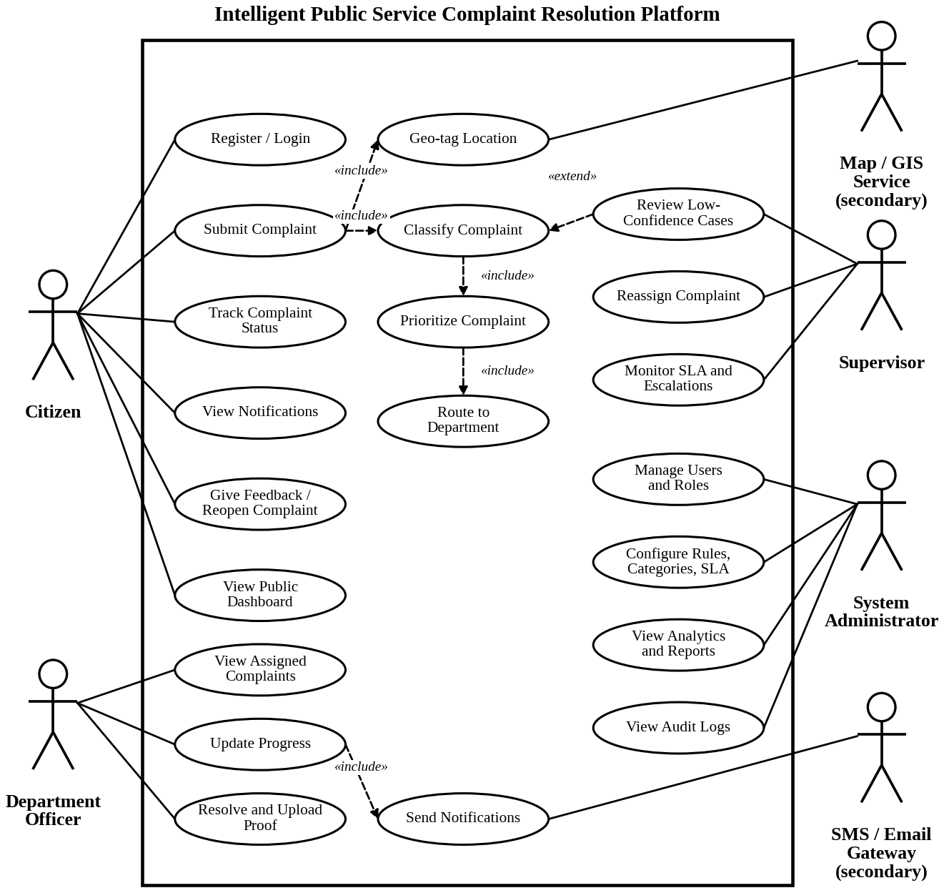
Fig. 2: Use case diagram of the complaint resolution platform
4. Software Requirement Specification (SRS)
4.1 Introduction
4.1.1 Purpose
This SRS describes the requirements of the Intelligent Public Service Complaint Resolution Platform. It is written for the development team, testers, department managers and the evaluator so that everybody has the same understanding of what has to be built. The structure follows the common IEEE 830 / ISO 29148 outline.
4.1.2 Definitions and Abbreviations
SLA is the Service Level Agreement, the time within which a complaint must be resolved. RBAC is Role Based Access Control. OTP is the One Time Password used for verification. API / REST is the web interface style using HTTP and JSON. CI/CD is Continuous Integration and Continuous Deployment. Confidence score is a value between 0 and 1 showing how sure the classifier is about the category.
4.1.3 References
- IEEE Std 830-1998, Recommended Practice for Software Requirements Specifications
- ISO/IEC/IEEE 29148, Systems and software engineering, Requirements engineering
- Problem statement 34, CSA10 Software Engineering assessment sheet, SIMATS Engineering
4.2 Problem Description
Complaints about civic services arrive through many routes and are handled by people who read each one, decide the department and forward it. When the volume is high this step alone takes days. Urgent matters are not separated from minor ones, nobody can easily see which complaints are close to missing their deadline, and the citizen hears nothing until the work is done, if at all. The proposed platform automates the repetitive decisions (classification, priority, routing, reminders) but keeps the human in control through review queues, overrides and audit records.
4.3 Scope of the System
Table 8: Scope
In scope | Out of scope
Complaint submission through web and mobile application | Actual field work or repair activity carried out by the departments
Automatic classification, priority scoring and routing | Payment of bills, taxes or fines
Workflow, SLA tracking, escalation and reassignment | Emergency services (police, fire, ambulance) call handling
Notifications by SMS, email and in-app message | Replacing the internal systems of departments such as billing or asset management
Dashboards, reports, audit trail and administration | Voice call and automated chat channels in the first release
Secure APIs, automated testing, CI/CD and monitoring | Hardware purchase for the departments

4.3.1 System Overview (Block Diagram)
The platform uses a layered design. Users reach it through the web and mobile applications. All calls pass through an API gateway that checks identity and role. Business functions are separated into small services that talk to each other using an event queue, so that classification or notification can be scaled or changed without touching the rest. Data is kept in the relational database, an object store for attachments and a reporting store. Monitoring and the CI/CD pipeline run alongside the platform.
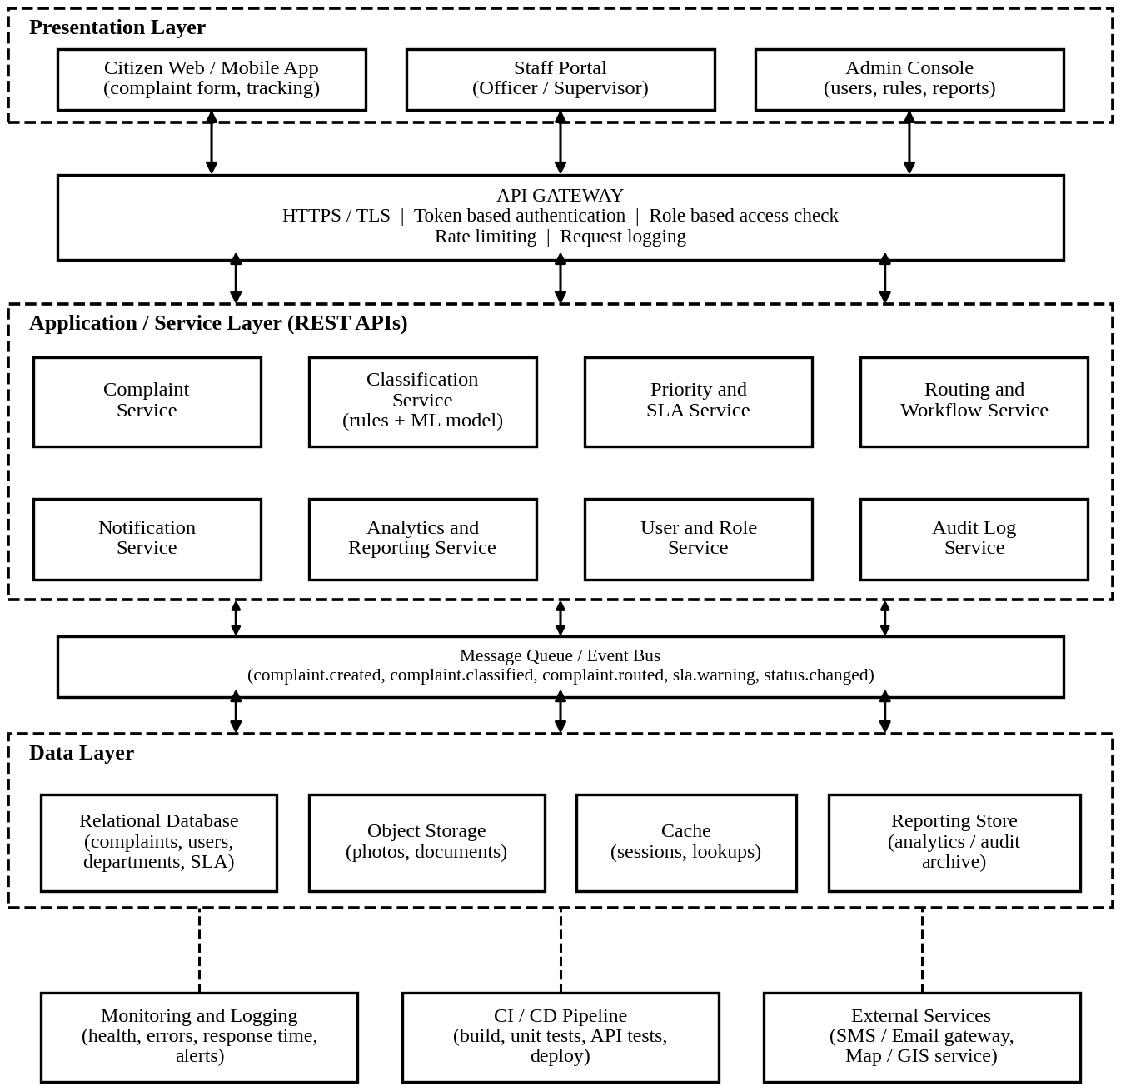
Fig. 3: Layered architecture of the platform
4.4 Functional Requirements
The complete list of functional requirements FR-01 to FR-34 is given in Table 4. They are divided into nine modules (A to I), which is also how the work is planned: 34 requirements in total, of which 26 are Must-have.

4.5 Non-Functional Requirements
The non-functional requirements NFR-01 to NFR-15 in Table 5 form part of this SRS. Three of them carry the most weight for this system and drive the design: security and privacy (NFR-06, NFR-07), because citizen data is handled; transparency (NFR-10), because the problem statement asks for classification that can be reviewed; and scalability (NFR-03), because complaint volume rises sharply after events such as heavy rain.
4.6 Use Case Descriptions
The most important use cases are described in detail below. The remaining ones follow the same pattern and are covered by the functional requirements.
Table 9: UC-02 Submit Complaint
Primary actor | Citizen
Secondary actors | Map / GIS Service, SMS / Email Gateway
Description | Citizen reports a civic problem with details, location and optional photos.
Precondition | Citizen is registered and logged in.
Main flow | 1. Citizen opens the new complaint form.  2. Citizen enters description, selects location on the map and attaches photos.  3. System validates the input and file types.  4. System geo-tags the location through the Map service.  5. System saves the complaint with status Submitted and generates the complaint ID.  6. System triggers classification (UC-04) and shows the acknowledgement.
Alternate flow | 3a. Input invalid: system shows the error and returns to the form.  5a. Duplicate found: system links the complaint to the open one and informs the citizen.
Postcondition | Complaint is stored, classified and the citizen has the complaint ID.
Business rule | A maximum of five attachments, each up to 10 MB.

Table 10: UC-04 Classify and Prioritize Complaint (includes UC-05)
Primary actor | Platform (triggered by UC-02)
Description | The system assigns category, sub-category, confidence score and priority level to a new complaint.
Precondition | Complaint exists with status Submitted.
Main flow | 1. System reads the complaint text and location.  2. Classification service predicts the category and confidence, and stores the matched keywords.  3. If confidence is at or above the threshold, status changes to Classified.  4. Priority service calculates the score from urgency, impact, location sensitivity and repeat reports.  5. System sets the priority level and the SLA target.  6. System starts routing (UC-06).
Alternate flow | 3a. Confidence is below the threshold: status becomes Under Review and the complaint goes to the supervisor queue (UC-14).
Postcondition | Complaint has category, priority, SLA target and a decision log entry.
Business rule | Threshold and weights are configurable by the administrator (UC-18).

Table 11: UC-06 Route to Department
Primary actor | Platform
Description | Complaint is sent to the department responsible for the category and ward, and to a suitable officer.
Precondition | Complaint is classified and has a priority.
Main flow | 1. System finds the department from the category and ward mapping.  2. System selects an officer of that zone with the lowest open workload.  3. Status changes to Routed and then Assigned.  4. System sends notifications to the officer and the citizen (UC-21).
Alternate flow | 2a. No officer is available: complaint stays in the department queue and the supervisor is alerted.  4a. Officer declines: complaint returns to the supervisor for reassignment (UC-15).
Postcondition | Complaint is owned by one officer and the SLA timer is running.

Table 12: UC-12/13 Update Progress and Resolve Complaint
Primary actor | Department Officer
Secondary actors | SMS / Email Gateway
Description | Officer records the work done and closes the task with proof.
Precondition | Complaint is assigned to the officer and accepted.
Main flow | 1. Officer opens the assigned complaint (UC-11).  2. Officer changes status to In Progress and adds a note.  3. System notifies the citizen of the change.  4. After the work, officer marks Resolved and uploads proof.  5. System stops the SLA timer and asks the citizen to confirm.
Alternate flow | 2a. Work belongs to another department: officer transfers the complaint with a note.
Postcondition | Complaint is Resolved and waiting for citizen confirmation.

Table 13: UC-14 Review Low-Confidence Classification
Primary actor | Supervisor
Description | Supervisor checks complaints that the system could not classify with enough confidence.
Precondition | Supervisor is logged in and the review queue has complaints.
Main flow | 1. Supervisor opens the review queue.  2. System shows the complaint, suggested category and matched keywords.  3. Supervisor accepts or corrects the category and enters a reason if corrected.  4. System saves the decision in the audit log and continues with prioritization and routing.
Alternate flow | 3a. Supervisor marks the complaint as Rejected or Duplicate with a reason.
Postcondition | Complaint leaves the queue, and the correction is stored for later improvement of the rules.

Table 14: UC-16 Monitor SLA and Escalate
Primary actor | Supervisor
Secondary actors | SMS / Email Gateway
Description | The system watches SLA timers and warns or escalates; the supervisor follows the list of at-risk complaints.
Precondition | Complaints with running SLA timers exist.
Main flow | 1. System checks timers at fixed intervals.  2. At 75% of the time, a warning goes to the officer.  3. On breach, the complaint is marked Breached and escalated to the supervisor.  4. Supervisor reassigns or follows up with the officer.  5. If still open after the next interval, it is escalated to the department head.
Postcondition | Every escalation is recorded with time and reason.

4.7 Data Requirements
The platform stores operational data (complaints, assignments, status history), reference data (categories, departments, SLA policies) and control data (users, roles, audit logs). The main entities are listed in Table 15 and their relations are shown in Figure 4.
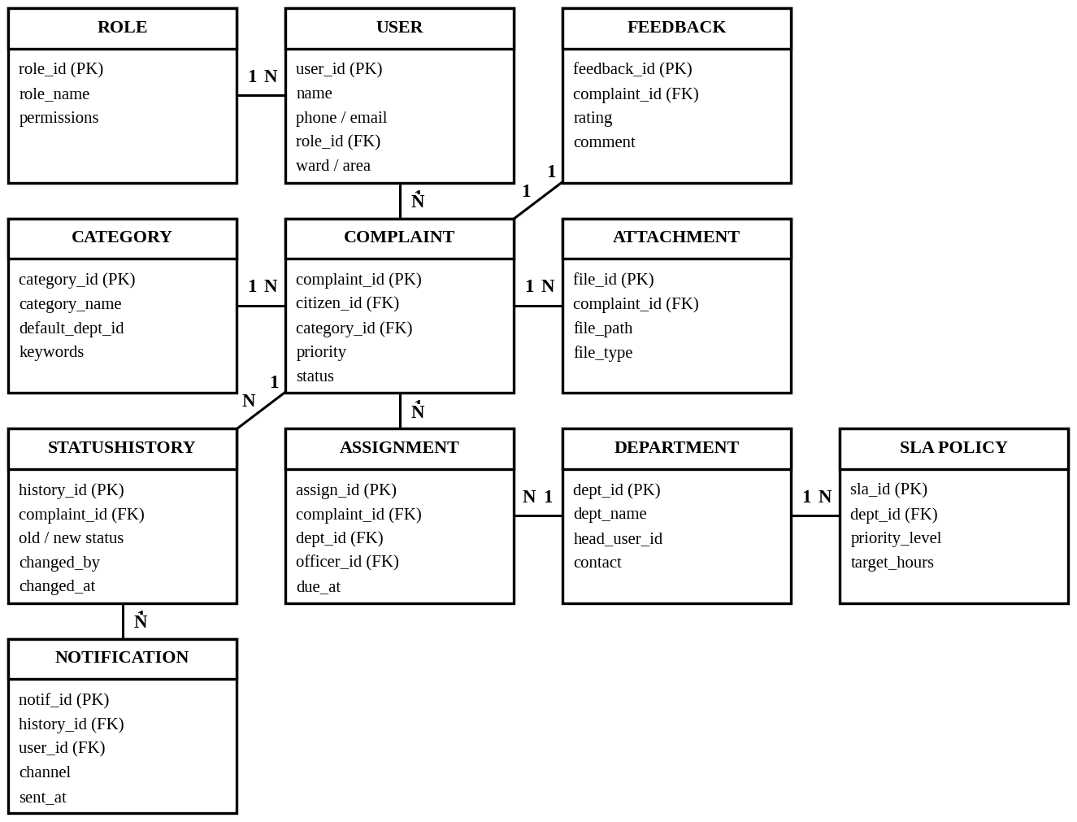
Fig. 4: Entity relationship block diagram
Table 15: Main data entities
Entity | Purpose | Important attributes | Retention
User | Citizens and staff accounts | user_id, name, phone/email, role_id, ward | While account is active
Role | Access rights | role_id, role_name, permissions | Permanent
Complaint | Core record of each complaint | complaint_id, citizen_id, category_id, description, location, priority, status, confidence | 5 years
Category | Complaint types and default department | category_id, name, keywords | Permanent
Attachment | Photos and documents | file_id, complaint_id, path, type | 5 years
Assignment | Which officer and department handle a complaint | assign_id, complaint_id, dept_id, officer_id, due_at | 5 years
Status History | Every status change | complaint_id, old_status, new_status, changed_by, changed_at | 5 years
Department | Responsible departments | dept_id, name, head, contact | Permanent
SLA Policy | Target hours by department and priority | sla_id, dept_id, priority_level, target_hours | Permanent
Notification | Messages sent | notif_id, history_id, user_id, channel, sent_at | 1 year
Feedback | Citizen rating after resolution | feedback_id, complaint_id, rating, comment | 5 years
Audit Log | Read-only record of all actions | log_id, user_id, action, entity, timestamp | 5 years

4.7.1 Data Dictionary (Complaint)
The Complaint entity is the core record of the platform, so its fields are described in detail in Table 16.
Table 16: Data dictionary of the Complaint entity
Field | Type | Size | Rule
complaint_id | String | 14 | Primary key, format CMP followed by the date and a 4 digit number, unique
citizen_id | Integer | - | Foreign key to User, mandatory
category_id | Integer | - | Foreign key to Category, filled by classification
description | Text | 2000 | Mandatory, minimum 20 characters
location | Lat/Long + text | - | Mandatory, address and ward derived from the map service
priority | List | - | Critical, High, Medium, Low
status | List | - | One of the statuses in FR-19
confidence | Decimal | 3,2 | Between 0.00 and 1.00
created_at | Timestamp | - | Set by the system, not editable

4.7.2 Data Rules
- Personal data (name, phone, email) is stored encrypted and is shown only to roles that need it.
- Audit log and status history records cannot be edited or deleted through the application.
- Attachments are scanned for file type and size before saving.
- Data older than the retention period is archived to the reporting store and then removed from the live tables.
4.8 External Interface Requirements
Table 17: External interfaces
Type | Requirement
User interface | Citizen web and mobile screens: login, new complaint, my complaints, complaint timeline, notifications, public dashboard.  Staff screens: task list, complaint detail, review queue, SLA watch list, analytics.  Admin screens: users and roles, categories and rules, SLA settings, audit log.  All screens are responsive, use simple language and support the local language.
Hardware interface | No special hardware at the user end. Users need a smartphone or computer with a camera for photos and an internet connection. Servers are cloud or data center virtual machines.
Software interface | Relational database; object storage; message queue; SMS and email gateway APIs; Map / GIS API for address and ward lookup.
Communication interface | HTTPS (TLS 1.2 or higher) for all traffic, JSON messages, token-based authentication, callback for SMS delivery status.

The main REST endpoints of the platform are listed in Table 18. All of them need a valid token and the role check is done on the server for every call.
Table 18: Main REST API endpoints
Method | Endpoint | Purpose | Allowed roles
POST | /api/auth/login | Login and get token | All
POST | /api/complaints | Submit a complaint | Citizen
GET | /api/complaints/{id} | View complaint and timeline | Owner, assigned staff, supervisor
PATCH | /api/complaints/{id}/status | Update status with note | Officer, Supervisor
POST | /api/complaints/{id}/reassign | Reassign to another officer or department | Supervisor
POST | /api/complaints/{id}/feedback | Rating or reopen request | Citizen
GET | /api/review-queue | Low-confidence complaints | Supervisor
GET | /api/analytics/summary | Dashboard figures | Supervisor, Admin
PUT | /api/admin/rules | Update category, SLA and priority rules | Admin
GET | /api/audit-logs | Search audit trail | Admin
GET | /api/health | Health check for monitoring | Monitoring system

4.9 System Features
Table 19: System features
No. | Feature | Description | Related requirements
SF-1 | Complaint intake | Form with location and attachments, duplicate check, acknowledgement | FR-04 to FR-08
SF-2 | Smart classification | Category, confidence and explanation; low confidence goes to review | FR-09 to FR-12, FR-32
SF-3 | Priority and SLA engine | Scores each complaint and sets the target time; supervisor override | FR-13 to FR-15
SF-4 | Routing and workflow | Department and officer assignment, accept or decline, transfer, status flow | FR-16 to FR-21
SF-5 | SLA monitoring and escalation | Timers, 75% warning, breach escalation chain | FR-22, FR-23
SF-6 | Citizen notifications and tracking | Messages on every change, timeline, feedback, public dashboard | FR-24 to FR-27
SF-7 | Analytics and reporting | Dashboards and exports for management | FR-28, FR-29
SF-8 | Administration and audit | Users, roles, rules, audit log, decision log | FR-02, FR-03, FR-30 to FR-31
SF-9 | Platform services | Secured APIs, health checks, metrics, pipeline | FR-33, FR-34

4.9.1 Complaint Status Life Cycle
Figure 5 shows the states a complaint can be in and the events that move it from one state to another. These are the same statuses used in FR-19.
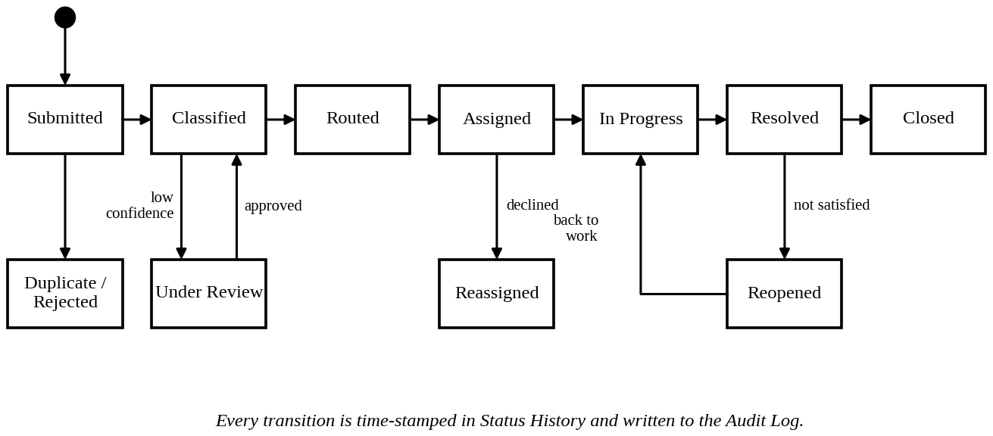
Fig. 5: State diagram of a complaint
4.9.2 Priority and SLA Flow
The priority score is the sum of four factors. Urgency (0-5) depends on danger to life or health, impact (0-5) on the number of people affected, location sensitivity (0-3) on nearness to hospitals or schools, and repeat reports (0-2) on how many citizens reported the same issue. The score range decides the level and the SLA target as in Figure 6.
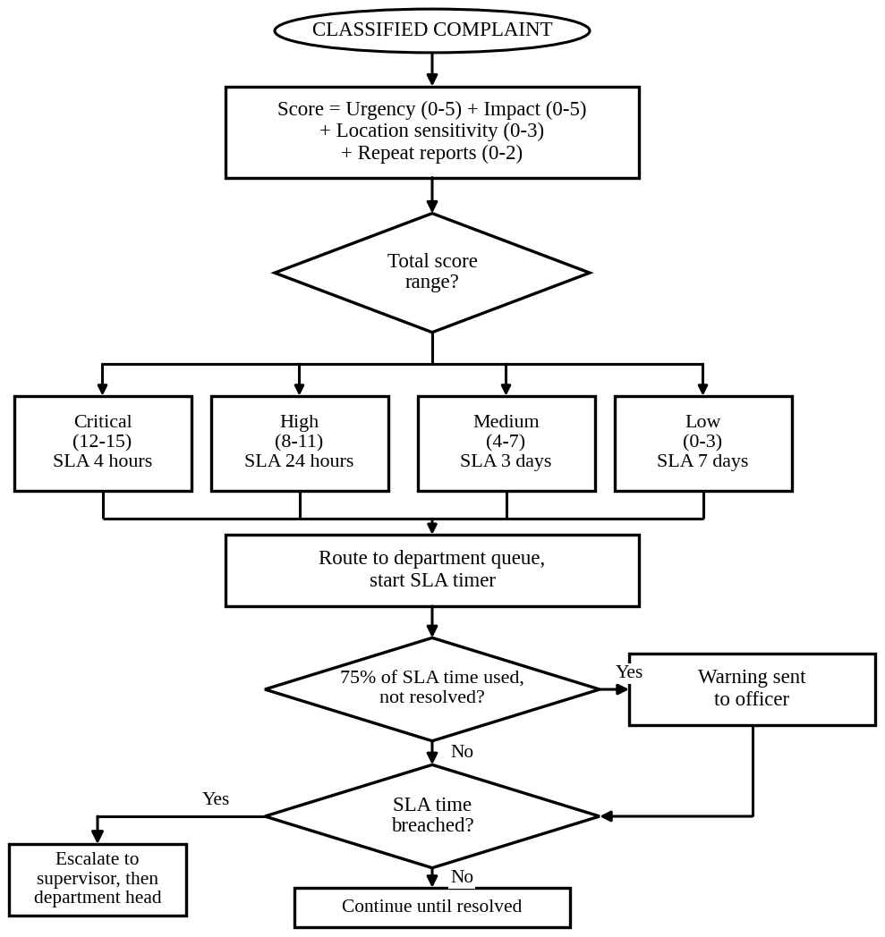
Fig. 6: Flow chart of priority calculation and SLA escalation
4.9.3 Complaint Processing Flow
Figure 7 shows the full life of a complaint from submission to closure as a flow chart. The left column covers submission, classification and prioritization, and the connector A continues into the right column, which covers routing, resolution and closure.
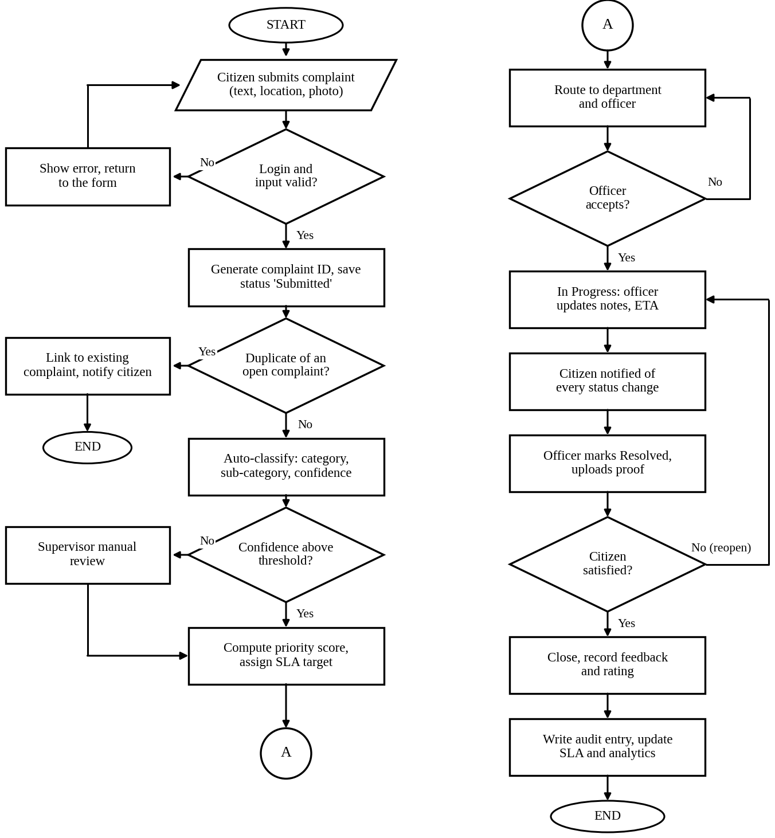
Fig. 7: Flow chart of complaint processing from submission to closure
5. Assumptions and Constraints
5.1 Assumptions
Table 20: Assumptions
No. | Assumption
A1 | Citizens have a mobile phone or internet access and a valid mobile number or email for OTP.
A2 | Every department has a named head, officers and a ward or zone list, and the administrator will enter them before go-live.
A3 | A list of complaint categories and keywords is available from the organization and will be used to train and test the classifier.
A4 | Past complaint records (even a few thousand) can be provided for testing the classification accuracy.
A5 | SMS and email gateway services and a map service are available through paid or free APIs.
A6 | Departments accept the SLA targets, and the targets are decided by management, not by the software team.
A7 | Staff will receive basic training on the staff portal before use.
A8 | The organization will provide cloud or data center infrastructure for deployment.
A9 | Emergency complaints are handled by a separate emergency number and not by this platform.
A10 | The first release supports one city or district; the design allows more regions later.

5.2 Constraints
Table 21: Constraints
Type | Constraint
Technical | Must run in a standard browser and on low-end Android phones.  Must use open standard APIs (REST/JSON) so that other systems can integrate.  Automatic classification must always be open to review, so a fully black-box model without explanation is not allowed.
Operational | Departments work in fixed shifts, so SLA clocks must follow working hours as configured.  Staff in some offices have slow internet, so the staff portal must be light.  Changes to rules must not need a new deployment.
Economic | Budget is limited for a public body, so open source tools are preferred.  SMS charges depend on volume, so in-app and email notifications are encouraged.  Hosting cost must scale with usage.
Legal | Citizen personal data must be handled as per the applicable data protection law of the country.  Audit records must be kept for the period required by government record rules.  The public dashboard must not reveal personal details.
Time | The project follows a fixed academic or release schedule, so the Must-have requirements are built first and Could-have items are left for later releases.  Testing and CI/CD setup must be completed before pilot use.

6. Validation of Requirement Completeness and Consistency
6.1 Stakeholder Coverage
Each stakeholder need from Section 1 and each objective in Table 3 was checked against the requirements to see whether anything is left uncovered. Objectives O1 to O7 are covered by FR-04 to FR-12, FR-13 to FR-15, FR-16 to FR-21, FR-19 and FR-22 to FR-23, FR-24 to FR-29, FR-33 to FR-34, and FR-10, FR-14, FR-31 and FR-32 respectively.
Table 22: Coverage of stakeholder needs
Stakeholder need | Covered by | Status
Citizen: easy filing and quick acknowledgement | FR-04, FR-06, NFR-01, NFR-08 | Covered
Citizen: regular updates and tracking | FR-24, FR-25, FR-27 | Covered
Citizen: a way to disagree with the result | FR-26, UC-09 | Covered
Officer: clear task list and simple update | FR-17 to FR-20, UC-11 to UC-13 | Covered
Supervisor: control and early warning | FR-11, FR-12, FR-14, FR-22, FR-23 | Covered
Administrator: configuration without code change | FR-03, FR-30, NFR-09 | Covered
Management: measurable performance | FR-15, FR-28, FR-29 | Covered
Public: transparency | FR-27, FR-31, FR-32, NFR-10 | Covered
Operations team: testing, CI/CD, monitoring | FR-34, NFR-12, NFR-13 | Covered

6.2 Check for Ambiguity, Redundancy, Inconsistency and Missing Requirements
Table 23: Review findings and corrections
Check | Finding | Action taken
Ambiguity | Words such as fast, quickly and easy were used in the first draft. | Replaced by measurable values in Table 5 (3 s, 500 ms, 3 minutes).
Ambiguity | The term urgency and impact were not defined. | Score ranges and factors defined in Section 4.9.2.
Redundancy | Audit and decision log looked like the same thing. | Kept separate: FR-31 is for all actions, FR-32 for automated decisions.
Inconsistency | Status names in the use cases differed from the workflow list. | All documents now use the statuses of FR-19.
Inconsistency | Retention of 5 years in data rules but 1 year for notifications. | Intended: notifications are not records of decision, so 1 year is stated clearly in Table 15.
Missing | No requirement for duplicate complaints. | FR-07 added.
Missing | No way for a citizen to reject a resolution. | FR-26 and UC-09 added.
Missing | No requirement for monitoring of the platform itself. | FR-34, NFR-13 added.

6.3 Suggested Improvements
- Add a messaging app or voice channel in the next release to reach citizens who do not use the application.
- Use the supervisor corrections from UC-14 to train the classifier again at fixed intervals and report the accuracy on the dashboard.
- Prepare acceptance test cases for every Must-have requirement so that each one can be verified.
6.4 Conclusion
The scenario was studied, the stakeholders and challenges were identified, and 34 functional and 15 non-functional requirements were written and prioritized. The SRS is supported by a use case diagram, block diagrams, flow charts, a state diagram and an entity relationship diagram. The validation shows that every objective of the problem statement is traced to at least one requirement, and the issues found during review have been corrected.
Rubrics for Calculation
Criteria | Excellent (4 Marks) | Good (3 Marks) | Satisfactory (2 Marks) | Needs Improvement (1 Mark)
Scenario Understanding and Problem Analysis (30%) | Demonstrates thorough understanding of the scenario, stakeholders, objectives, and business context with clear analysis. | Demonstrates good understanding with minor omissions. | Basic understanding with limited analysis. | Poor understanding; major aspects missing or incorrect.
Functional and Non-Functional Requirement Identification (25%) | Clearly identifies comprehensive, accurate, and well-classified functional and non-functional requirements. | Identifies most requirements with minor classification errors. | Identifies only basic requirements; several omissions. | Requirements are incomplete, inaccurate, or poorly classified.
Actor Identification and Use Case Modelling (20%) | Correctly identifies all relevant actors and use cases; use case diagram is complete, accurate, and follows UML standards. | Most actors and use cases identified; diagram has minor errors. | Limited actors/use cases identified; diagram partially correct. | Actors/use cases missing or incorrect; diagram absent or inaccurate.
Software Requirement Specification (SRS) Documentation (15%) | SRS is well-structured, complete, professionally organized, and includes all required sections. | SRS is organized with minor missing sections or formatting issues. | SRS includes only essential sections with limited detail. | SRS is incomplete, poorly organized, or lacks essential components.
Assumptions, Constraints, and Requirement Validation (10%) | Clearly identifies realistic assumptions and constraints; validates requirements for completeness, consistency, and ambiguity with appropriate justification. | Identifies most assumptions and constraints; validation is adequate. | Limited assumptions/constraints; validation is superficial. | Assumptions, constraints, and validation are missing or incorrect.

Criteria | Mark
Scenario Understanding and Problem Analysis (30%) | /5
Functional and Non-Functional Requirement Identification (25%) | /5
Actor Identification and Use Case Modelling (20%) | /5
Software Requirement Specification (SRS) Documentation (15%) | /5
Assumptions, Constraints, and Requirement Validation (10%) | /5
TOTAL | /25

